**Types OF Framework**

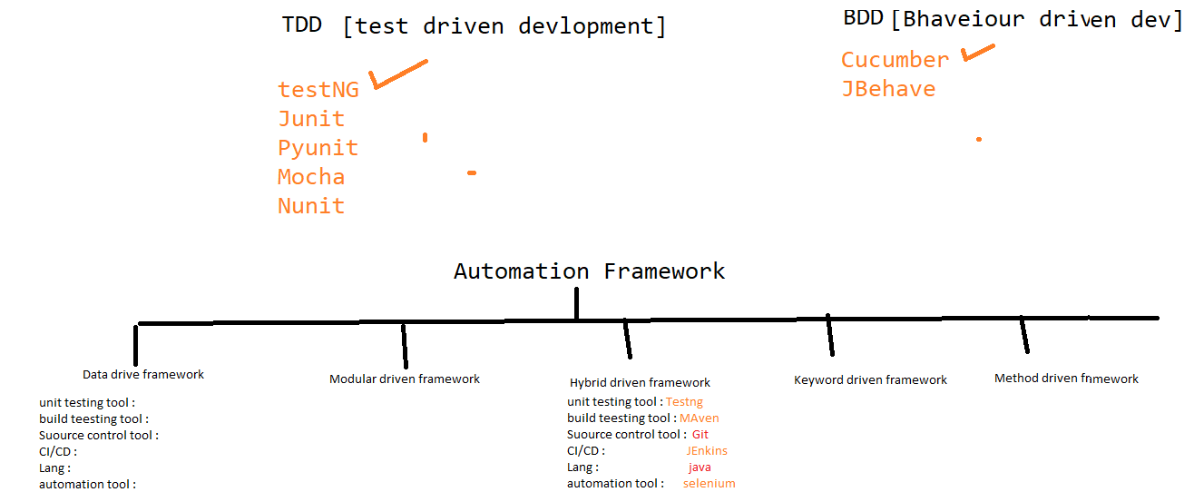

1. Data drive framework
2. Modular driven framework
3. Hybrid driven framework
4. Keyword driven framework
5. BDD framework

**What is Data driven Framework**

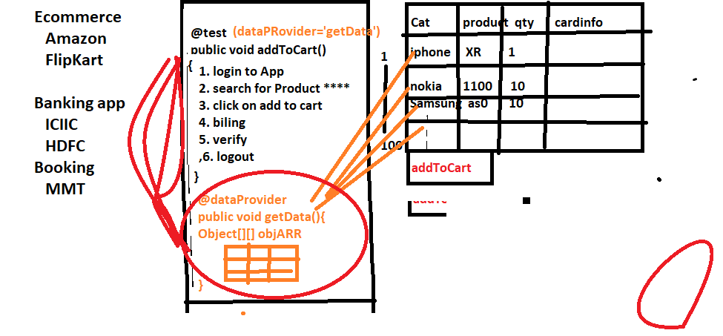

Whenever we need to test the application with huge set of data, we go for data driven framework

In data driven framework every test case will have dedicated @DataProvider annotation & will have separate excel sheet for every test

@DataProvider

Whenever we need to execute same test with different set of data we go for DataProvider annotation.

**What is modular driven framework**

Whenever application is huge / contains lots of modules we prefer modular driven framework

In modular driven framework, all framework components will maintain in module wise.

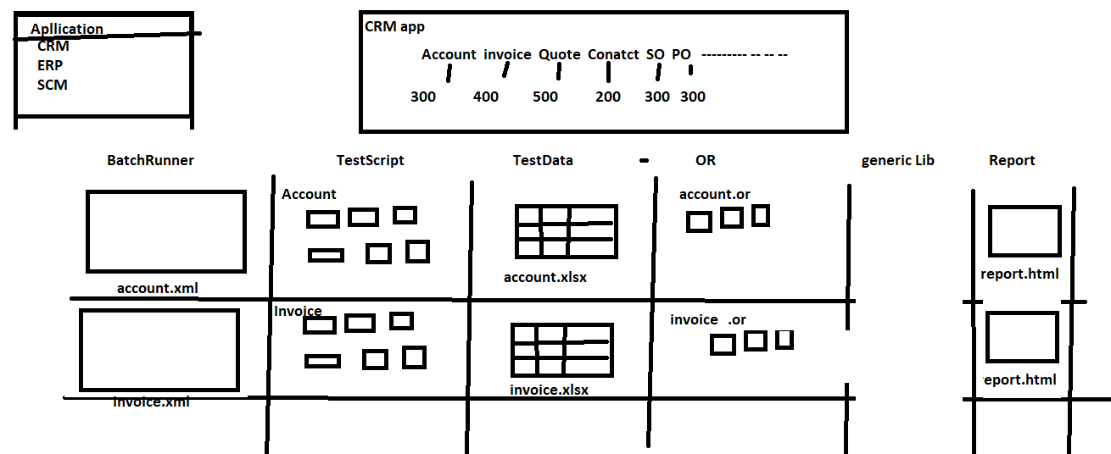

**What is Keyword driven Framework**

When manual test Engineer want to write Automation test script with less knowledge on automation tool & without the knowledge of coding we go for keyword Driven framework.

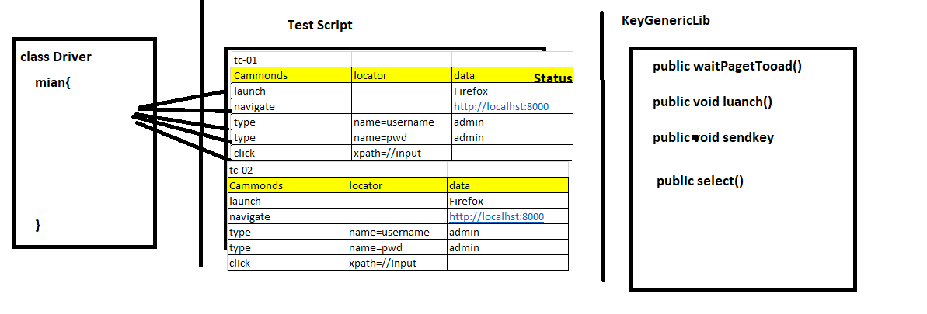

**Hybrid driven framework**

Combination of more than one framework is called hybrid driven framework

EG: The framework which we designed is hybrid because its combination of data driven + Modular driven + keyword driven framework + Method driven.

**BDD (Behaviour Driven Development) Framework**



